Magnetization Properties

1. Introduction

Measure the magnetization curves of a variety of magnetic materials to understand the basic concepts of ferromagnetism. Understand the properties of Silicon steel, Amorphous, ferrite under different frequency, temperature. Learn the method of using X-Y recorder and oscilloscope to record the data.

2. Experimental results

2.1 Properties of specimens and different materials

The basic information of specimens is shown on Table 2.1 *Properties of specimens*.

Table 2.1: Properties of specimens

|  |  |  |  |  |
| --- | --- | --- | --- | --- |
| Material | Le m | Ae | turn | turn |
| Silicon steel |  |  | 30 | 30 |
| Amorphous |  |  | 5 | 5 |
| Ferrite |  |  | 15 | 15 |

Where, is the average length of the inner and outer perimeters of the toroidal specimen, is the cross-sectional area, and turns are the turns of the coil.

Below are the equations to calculate:

|  |  |  |
| --- | --- | --- |
|  |  | (2.1) |
|  |  | (2.2) |

The measurement parameters used in Experiment are shown as Table 2.2 *Measurement parameters*.

Table 2.2: Measurement parameters

|  |  |  |  |
| --- | --- | --- | --- |
| Material | Maximum excitation current | Frequency Hz | Temperature ℃ |
| Silicon steel | 0.6 | 100, 200, 500 | 24 |
| Amorphous | 0.3 | 1000 | 24 |
| Ferrite | 0.8 | 1000 | 0, 24, 70 |

2.2 Measurement of the magnetization curves

The relationship between K1 and K2 constant and

The data from X-Y Recorder and B-H Curve Trainer is shown on Table 2.3 *Measurement result* *of X-Y Recorder* and Table 2.4 *Measurements of the AC B-H Curve Trainer.* Where K1 and K2 are the code number displayed on the AC magnetic properties measurement instrument.

Scale Factors of the coercivity H and the flux density B can be calculated using Equation (2.3) and Equation (2.4). 1

|  |  |  |
| --- | --- | --- |
|  |  | (2.3) |

|  |  |  |
| --- | --- | --- |
|  |  | (2.4) |

The definitions of each parameters can be referred to Clause 2.1.

Example calculations for Silicon steel, we have:

|  |  |  |
| --- | --- | --- |
|  |  |  |

|  |  |  |
| --- | --- | --- |
|  |  |  |
|  |  |  |

While K1 and K2 are the code number displayed on the AC magnetic properties measurement instrument, is the average length of the inner and outer perimeters of the toroidal specimen, is the cross-sectional area, and turns are the turns of the coil, is the range of X axis, is the range of Y axis. The values can be referred to Table 2.1, Table 2.2 and Table 2.3.

Table 2.3: Measurement result of X-Y Recorder

|  |  |  |  |  |
| --- | --- | --- | --- | --- |
| hgMaterial | X-Y Recorder | | Scale Factors | |
| Range  X axis  V/cm | Range  Y axis  V/cm | H A/m/cm | B T/cm |
| Silicon  Steel | 0.5 | 0.1 | 35.76 | 0.163 |
| 0.5 | 0.1 | 35.76 | 0.163 |
| 0.5 | 0.1 | 35.76 | 0.163 |
| Amorphous | 0.5 | 0.5 | 4.55 | 0.085 |
| Ferrite  (H5A) | 0.25 | 0.25 | 28.14 | 0.082 |
| 0.25 | 0.25 | 28.14 | 0.082 |
| 0.25 | 0.25 | 28.14 | 0.082 |

Table 2.4: Measurements of the AC B-H Curve Trainer

|  |  |  |  |  |  |  |
| --- | --- | --- | --- | --- | --- | --- |
| Material | Hz | Temperature℃ | AC B-H Curve Trainer | | | |
| K1  Code number | K1  A/div | K2  Code number | K2  Wb-turn/div |
| Silicon  steel | 100 | 24 | 5 | 0.2 | 0.5 |  |
| 200 | 5 | 0.2 | 0.5 |  |
| 500 | 5 | 0.2 | 0.5 |  |
| Amorphous | 1000 | 24 | 4 | 0.1 | 0.5 |  |
| Ferrite  (H5A) | 1000 | 0 | 5 | 0.4 | 0.25 |  |
| 24 | 5 | 0.4 | 0.25 |  |
| 70 | 5 | 0.4 | 0.25 |  |

2.3 Readings from the graph and Measurement result

We can read the data from Fig. 2.1 *The hysteresis magnetization curve of silicon steel*, Fig. 2.2 *The hysteresis magnetization curve of amorphous* and Fig. 2.3 *The hysteresis magnetization curve of ferrite*, thus we have Table 2.4 *Readings from the graph and Measurement result* which contains values of coercivity Hc, the maximum magnetic flux density Bm, and the residual magnetic flux density Br.

And we can obtain the above values (Hc, Bm, Br) as shown if Fig. 2.4.

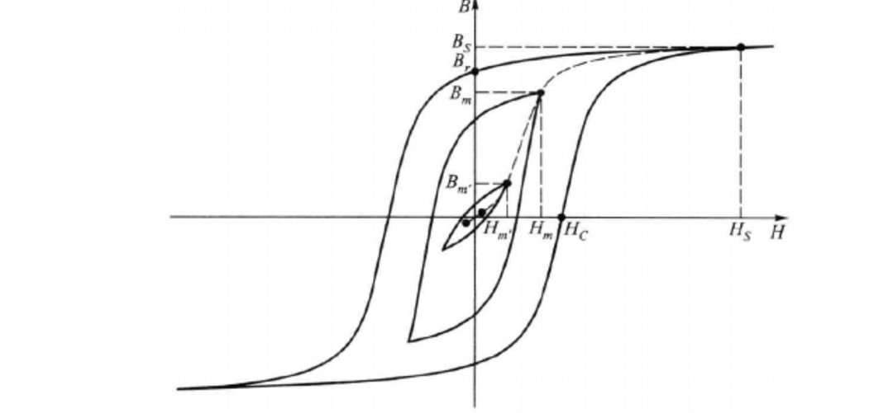

Fig. 2.4 Dynamic Hysteresis Curves10

Example calculation:

For Silicon steel of frequency 100Hz, Temperature of 24℃, we can calculate the values of Hc, Bm, Br by using the values of H and B obtained in Table 2.3:

Table 2.4: Readings from the graph and Measurement result

|  |  |  |  |  |  |  |  |  |
| --- | --- | --- | --- | --- | --- | --- | --- | --- |
| Material | Frequency Hz | Temperature℃ | Reading from the graph | | | Measurement result | | |
| Hc  cm | Br  cm | Bm  cm | Hc  A/m | Br  T | Bm  T |
| Silicon  steel | 100 | 24 | 1.46 | 5.38 | 6.80 | 52.21 | 0.88 | 1.11 |
| 200 | 1.80 | 5.69 | 6.73 | 64.37 | 0.93 | 1.10 |
| 500 | 2.43 | 5.88 | 6.69 | 86.90 | 0.96 | 1.09 |
| Amorphous | 1000 | 24 | 0.58 | 7.08 | 7.11 | 2.64 | 0.60 | 0.60 |
| Ferrite  (H5A) | 1000 | 0 | 0.46 | 1.00 | 5.31 | 12.94 | 0.08 | 0.44 |
| 24 | 0.41 | 1.00 | 4.90 | 11.54 | 0.08 | 0.44 |
| 73 | 0.31 | 0.88 | 3.91 | 8.72 | 0.07 | 0.32 |

3. Discussion and Conclusion

3.1 Frequency dependency of the hysteresis curve

We can learn from Fig.2.1 that as the frequency dependency increases, the area of hysteresis curve (hysteresis loss) increases and the maximum magnetic flux density stays the same.

The electric current induced in a conductor by a changing magnetic field is called eddy current11, thus there is eddy current in our experiment.

The derivation of the classic eddy current loss frequency obtained equation2 can be expressed as:

|  |  |  |
| --- | --- | --- |
|  |  | (3.1) |

While [Ω m] is defined as the resistivity, d[m] is defined as the cross-sectional dimension (thickness is for laminations, diameter is for cylinders or spheres) and is a geometrical factor which =16 in cylinders in our case, Bmax is defiend the peak flux density in the cycle and f [Hz] is the frequency.

And we can also learn Hysteresis loss in transformer’s Equation3:

|  |  |  |
| --- | --- | --- |
|  |  | (3.2) |

Where, Kh is the Hysteresis constant, Bmax is the peak flux density in the cycle and f is the frequency in Hz.

Anomalous loss14 is the loss in other than eddy-current and hysteresis losses. The Anomalous loss is defined as:

|  |  |  |
| --- | --- | --- |
|  |  | (3.3) |

while is the anomalous loss coefficient, is the maximum flux density, and is the frequency of reversal of magnetic field.

From Equation (3.1), (3.2) and (3.3), we can learn that the loss increases when the frequency increases, hence the area increases as well.

3.2 Temperature dependency of the hysteresis curve

We can learn from Fig 2.3 that as the temperature increases, the maximum magnetic flux density Bm decreases. And the coercivity Hc and the residual magnetic flux density Br shows no connections with the temperature.

Oxides that contain ions are generally called ferrite1. Ferrite contains a strong magnetic property called ferrimagnetism which the material contains atoms with opposing magnetic moments.

And Spontaneous magnetization13 is the magnetization that without being affected by external magnetic field in a ferromagnetic material below a critical point called the Curie temperature or TC.6

Spin wave10 is the propagating disturbances in the ordering of different materials, and ferromagnetic materials are dominated by spin wave when the temperature is above TC.

And the temperature dependence of spontaneous magnetization at low temperatures is given by Bloch's Law6:

|  |  |  |
| --- | --- | --- |
|  |  | (3.4) |

while M(0) is the spontaneous magnetization at absolute zero, and is the curie temperature which is around 771°C7.

And we can also learn that the decrease in spontaneous magnetization at higher temperatures is caused by the increasing excitation of spin waves8.

And therefore, according to Equation (3.4), we can find out that higher temperature would cause decrease in spontaneous magnetization, which will cause the decrease of maximum magnetic flux density

3.3 Relationship between the differences in shapes of the three samples

Coercivity12 is the resistance of a magnetic material to changes in magnetization. For low coercivity materials, we call them magnetically soft (Hc ~ 1A/m), for example, the ferrite in the experiment. It has characteristics like high Permeability, low intrinsic coercive force and hence the hysteresis curve is narrow.

For high coercivity materials, which are called magnetically hard (Hc ~ 104 ~106 A/m), the remanence is high and the coercivity is strong, which makes the hysteresis wide.10

3.4 For Dynamic Hysteresis Curves

And for different Dynamic Hysteresis Curves, the shapes are related to the frequency and ranges of the magnetic fields. For example, as Bm and Hm in Fig 3.1. *Dynamic Hysteresis Curves,* we have the equation for amplitude permeability:

|  |  |  |
| --- | --- | --- |
|  |  | (3.5) |

While Bm and Hm is magnetic field and flux density.



Fig. 3.1 Dynamic Hysteresis Curves10

4. References

1) Waseda university, Science and Engineering Laboratory 2A, Laboratory for Basic Experiments in Science and Engineering, pp.42-49, 2017.

2) Jiles, D. C. "Frequency dependence of hysteresis curves in'non-conducting'magnetic materials." IEEE Transactions on Magnetics 29.6 (1993): pp. 3490-3492.

3) De Leon, Francisco, and Adam Semlyen. "A simple representation of dynamic hysteresis losses in power transformers." IEEE Transactions on Power Delivery 10.1 (1995): pp.315-321.

4) Ball, P. C., and R. Evans. "Temperature dependence of gas adsorption on a mesoporous solid: capillary criticality and hysteresis." Langmuir 5.3 (1989): pp.714-723.

5) Bertotti, Giorgio. "Dynamic generalization of the scalar Preisach model of hysteresis." IEEE Transactions on Magnetics 28.5 (1992): 2599-2601.

6) Ashcroft, Neil W.; Mermin, N. David (1976). Solid State Physics. Holt, Rinehart and Winston. ISBN 0-03-083993-9.

7) Matsuki, H., and K. Murakami. "High quality soft heating method utilizing temperature dependence of permeability and core loss of low Curie temperature ferrite." IEEE Transactions on Magnetics 21.5 (1985): 1927-1929, pp.708

8) Chikazumi, Sōshin (1997). Physics of Ferromagnetism. Clarendon Press. ISBN 0-19-851776-9., pp. 128–129

9) Wilson, Peter R., J. Neil Ross, and Andrew D. Brown. "Optimizing the Jiles-Atherton model of hysteresis by a genetic algorithm." IEEE Transactions on Magnetics 37.2 (2001): pp. 989-993.

10) Zhang Yixiong. "Application of high order polynomials in fitting hysteresis loops of ferromagnetic materials." College Physics 27.2 (2008): pp. 45-45.

11) Dodd, C. V., and W. E. Deeds. "Analytical Solutions to Eddy‐Current Probe‐Coil Problems." Journal of applied physics 39.6 (1968): pp. 2829-2838.

12) Schrefl, Thomas, Josef Fidler, and H. Kronmüller. "Remanence and coercivity in isotropic nanocrystalline permanent magnets." Physical Review B 49.9 (1994): pp 6100.

13) Yang, Chen Ning. "The spontaneous magnetization of a two-dimensional Ising model." Physical Review 85.5 (1952): pp. 808.

14) Suyver, J. F., et al. "Anomalous power dependence of sensitized upconversion luminescence." Physical Review B 71.12 (2005): pp.123-123.